DIRECTOR
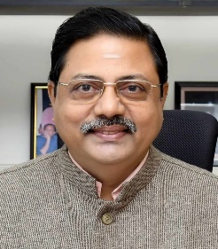
Shri M Mohan, Distinguished Scientist assumed the charge of Director, Liquid Propulsion Systems Centre, (LPSC) in the forenoon of 27th January, 2025. Before becoming Director, LPSC he held various key positions like Director (Projects), VSSC; Director of Human Space Flight Centre (HSFC); Associate Director, VSSC (R & D); Deputy Director, MME/VSSC; Deputy Director, ASOE/VSSC etc.

He was also the Project Director, GSLV and was the Mission Director for the successful missions of GSLV-F08/GSAT-6A and GSLV-F11/GSAT-7A, accomplished in the year 2018. He had also held the positions of Project Director, Cryogenic Upper Stage (CUS); Deputy Director, MME/LPSC and Project Director, Space Capsule Recovery Project (SRE-2). He held the responsibility of system leader of the Moon Impact Probe (MIP) Project of the Chandrayaan-1 Mission in 2008, which successfully placed the National Flag on the Moon surface.

He was the recipient of ISRO Performance Excellence Award in 2016 and ISRO Merit Award in 2010. He is a fellow of Aeronautical Society of India (AeSI), Life member and currently President of the Society of Aerospace Manufacturing Engineers (SAME) in India, Life member of High Energy Materials Society of India (HEMSI) and Life Member of Indian National Society for Aerospace and Related Mechanisms (INSARM).

UPDATED ON 02.02.2026

